# Academy VPC

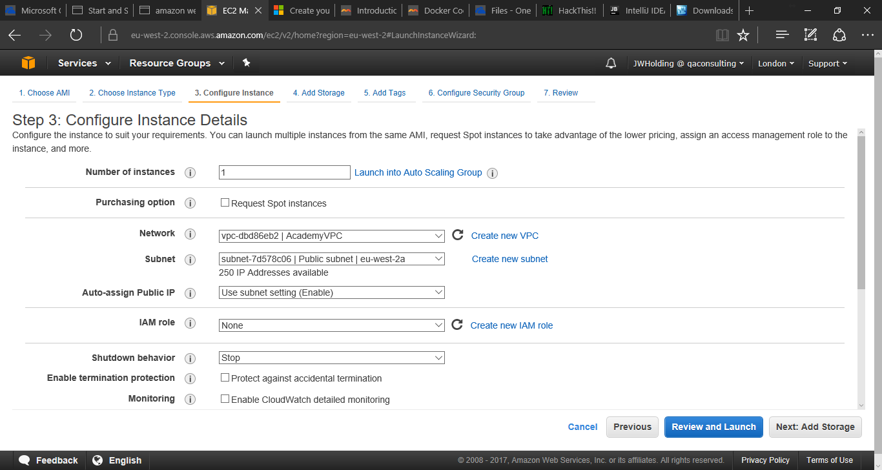There is now a virtual private cloud (VPC) created for academy use. This allows there to be separation of the training instances in the academy from any other that are created. When creating a machine on instance details page you need to change the network to AcademyVPC.

# Academy Security Group

There is a new security group setup called AcademySecurityGroup. Instead of all ports being open like they used to be there is currently only:

* TCP 80
* TCP 8080
* TCP 8081
* TCP 22
* TCP/UPD 53
* TCP 443
* ICMP – All

If any other ports need to be added it is quite easy to do by editing the security group in AWS.

At the moment, the firewall rules are for the IP address of the academy only, so a machine set with this security group is only accessible from the Manchester ANQ office.

# Academy Key Pair

I have created a new private key pair for use within the academy. The key will be available in the L:\ drive and is called AcademyKeyPair.ppk. This is password protected so when used trainees will need to use the password:

QAC

to unlock the key.

# Naming Convention

We will follow a naming convention from now on to make it clear which machines belong to the academy:

Academy:Name:Use:DDMM

e.g. Academy:Jacob:DockerExample:2505

# Managing the instances

Finally, it will be the trainer’s responsibility to ensure that all instances are shutdown at the end of each day and terminated when no longer needed. I am currently working on a method to automate this.